EXPERIMENT 1
Date: 12/10/2026

Transformation between Cartesian, Cylindrical and spherical coordinate system

Aim:
To write program for Transformation between Cartesian, Cylindrical and spherical coordinate system using MATLAB.

Software required:
MATLAB (R2018 or later)

Program:
Test case (i) Transformation of Cartesian coordinate points in to Cylindrical and spherical coordinate system
clc;
x=input('Enter the value of X=');
y=input('Enter the value of y=');
z=input('Enter the value of z=');

% Cartesian to Cylindrical
r=sqrt(x^2+y^2);
phi=atan2d(y,x);
disp('Cartesian to cylindrical coordinate system of p(r,phi,z)=');
disp([r phi z]);

% Cartesian to Spherical
R=sqrt(x^2+y^2+z^2);
theta=acosd(z/R);
phi=atan2d(y,x);
disp ('Cartesian to spherical coordinate system of s(r,theta,phi) =');
disp ([R theta phi]);
OUTPUT:
Enter the value of X=10
Enter the value of y=15
Enter the value of z=20
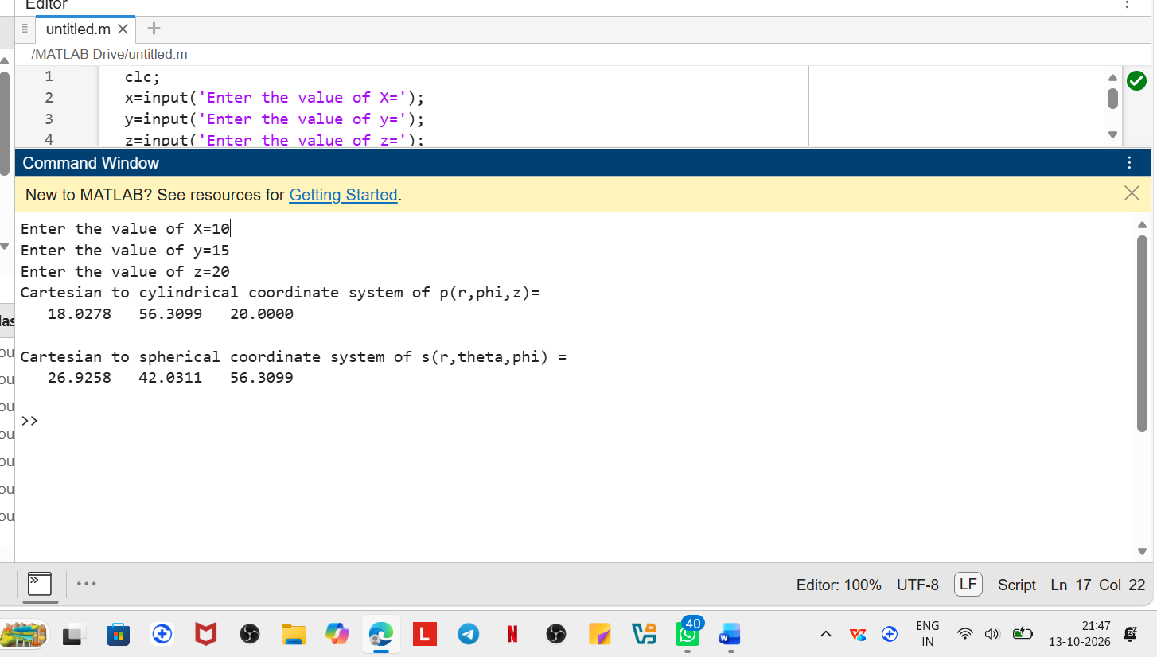

Test case (ii) Transformation of Cylindrical coordinate points into Cartesian and spherical coordinate system
clc;
r=input('Enter the value of r=');
phi=input('Enter the value of phi=');
z=input('Enter the value of z=');
% Cylindrical to Cartesian
x=r*cosd(phi);
y=r*sind(phi);
disp('cylindrical to cartesian coordinate system of p(x,y,z)=');
disp([x y z]);
% Cylindrical to Spherical
R=sqrt(r^2+z^2);
theta=acosd(z/R);
disp('cylindrical to spherical coordinate system of s(r,phi,theta)=');
disp([R phi theta]);
OUTPUT:-
Enter the value of r=10
Enter the value of pi=15
Enter the value of theta=20
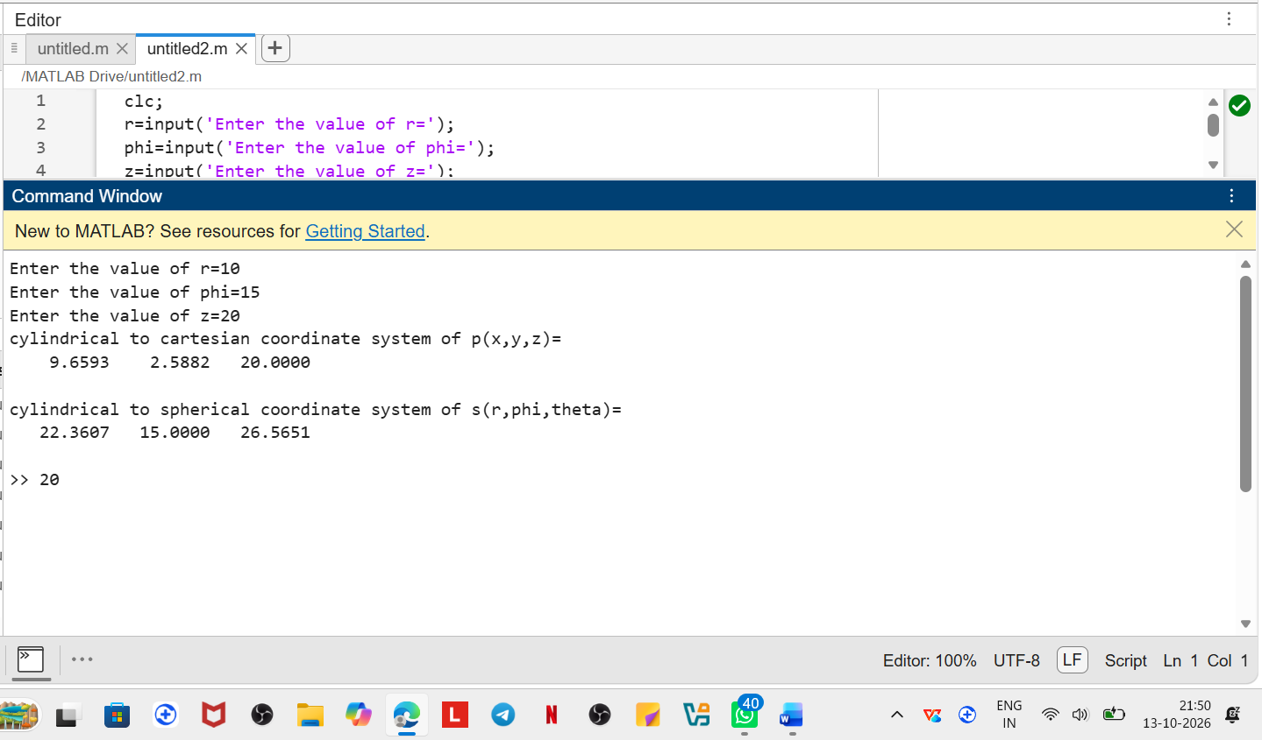
Test case (iii)Transformation ofspherical coordinate pointsinto Cylindrical and Cartesian coordinate system
PROGRAM:
clc;
r=input('Enter the value of r=');
phi=input('Enter the value of phi=');
theta=input('Enter the value of theta=');
% Spherical to Cartesian
x=r*sind(theta)*cosd(phi);
y=r*sind(theta)*sind(phi);
z=r*cosd(theta);
disp('spherical to cartesian coordinatesystem of p(x,y,z)=');
disp([x y z]);
% Spherical to Cylindrical
rho=r*sind(theta);
disp('spherical to cylindrical coordinate system of s(rho,phi,z)=');
disp([rho phi z]);

OUTPUT:-
Enter the value of r=10
Enter the value of pi=15
Enter the value of theta=20
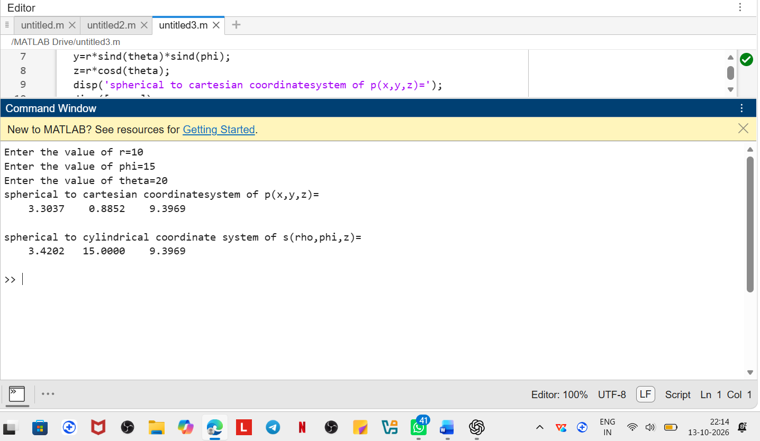
Parameters | Observed/Simulated Result | Theoretical Result | Error Difference
x = 10, y = 15, z = 20 | ρ = 18.027756, φ = 56.309932, z = 20; r = 26.925824, θ = 42.031114, φ = 56.309932 | ρ = 18.027, φ = 56.30, z = 20; r = 26.925, θ = 42.03, φ = 56.309 | Δρ = 0.000756, Δφ = 0.009932, Δr = 0.000824, Δθ = 0.001114
ρ = 10, φ = 15, z = 20 | x = 9.6592583, y = 2.588190, z = 20; r = 22.36068, φ = 15, θ = 48.189685 | x = 9.659, y = 2.588, z = 20; r = 22.360, φ = 15, θ = 48.189 | Δx = 0.000258, Δy = 0.000190, Δr = 0.00068, Δθ = 0.000685
r = 10, φ = 15, θ = 20 | x = 3.3036609, y = 0.8852133, z = 9.3969262; ρ = 3.4202014, φ = 15, z = 9.3969262 | x = 3.304, y = 0.885, z = 9.396; ρ = 3.420, φ = 15, z = 9.396 | Δx = 0.000339, Δy = 0.000213, Δz = 0.000926, Δρ = 0.000201

Result:
Thus, the program was verified Transformation between Cartesian and Cylindrical coordinate system its classified two categories
(a) Cartesian to cylindrical and spherical coordinate system
(b) Cylindrical to cartesian and spherical coordinate system
(c) spherical to cartesian and cylindrical coordinate system using MATLAB was successfully.
